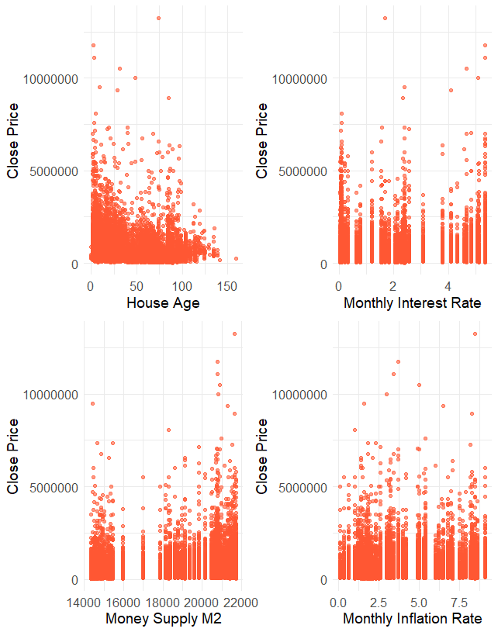

**Additional Variables we explored.**

We did additional analysis to explore factors such as Federal Interest rate, Inflation, Money Supply, and Migration trends. Based on the graph above, there is a clear relationship (inverse) between the closing price of a house to the age of the house which definitely makes intuitive sense. The relationship between the monthly interest rate and monthly inflation rate on the closing price did not seem to have a clear relationship, at least visually. We found a faint increasing trend of the closing price with the M2 money Supply.

When running a basic linear regression model with BathsTotal, BedsTotal, SqFtTotal and House_Age instead of Year_Built, we found the R-squared and adjusted R-squared to give a marginally better score. When we added monthly interest rate, monthly inflation rate or Money Supply variable to this linear model, we observed that the R-squared and adjusted R-squared did not get better but remained the same. This is not to say that these variables are not significant, they are, it is just that the R squared and adjusted R squared is already at the upper limit.

We were also interested in exploring the migration trends for Houston and its surrounding areas to check its effect on the price. We think that additional exploration for these variables (Federal Interest rate, Inflation, Money Supply, and Migration trends) along with running suitable models can enhance the understanding of the impacts on the housing market prices.

Additional code and explanation are available on our GitHub site.

Conclusion:

In our analysis of additional variables such as Federal Interest rate, Inflation, Money Supply, and Migration trends, we found an intuitive inverse relationship between house prices and age, and a faint increasing trend with M2 Money Supply. While substituting Year_Built with other factors marginally improved regression scores, further addition of interest rates, inflation, or Money Supply did not enhance the model. Exploring migration trends for Houston and its environs could provide valuable insights into housing price dynamics.